### **Objective Questions and Answers**

#### **Q1: What is the total number of attributes present in the data?**

**Answer**: **Ticket Table**: 10 attributes **IT Agent Table**: 6 attributes

**Approach**: Count the number of columns (attributes) in each table (Ticket Table and IT Agent Table). In Excel, you can simply view the number of column headers to determine the count of attributes.

**Insights**: Total attributes: 16, indicating a moderately detailed dataset.

**Recommendation**: Use these attributes for in-depth analyses to address operational and performance challenges effectively.

#### **Q2: Which columns have inconsistent or missing values, and what is the count of such values?**

**Answer**: There are no columns with missing or inconsistent values. The count is **0**.

**Approach**: Use Excel's **Data Validation** feature. You can also use conditional formatting to highlight inconsistent data entries.

**Insights**: Clean data ensures reliable and accurate analysis.

**Recommendation**: Maintain data quality during updates to prevent future issues.

#### **Q3: What is the average daily ticket volume over time?**

**Answer**: **53.36 tickets per day**.

**Approach**:

1. Use a **pivot table** to sum the total number of tickets by day.
2. Divide the total number of tickets by the total number of days in the dataset using the formula: =Total Tickets / Number of Days.
3. Here is the formula for sheet -> =COUNTA(Tickets!A:A) / (DATEDIF(MIN(Tickets!B:B), MAX(Tickets!B:B), "D") + 1)

**Reference Image**:

 **Insights**: Consistent ticket volume highlights the need for stable support resources.

**Recommendation**: Plan staffing and resources based on ticket trends.

#### **Q4: What is the distribution of ticket categories (e.g., Login Access, System, and Software)?**

**Answer**:

**Hardware**: Number of Tickets: **9,733** Percentage: **9.98%**

**Login Access**: Number of Tickets: **29,193** Percentage: **29.94%**

**Software**: Number of Tickets: **19,570** Percentage: **20.07%**

**System**: Number of Tickets: **39,002** Percentage: **40.00%**

**Approach**: Use a **pivot table** to count the number of tickets in each category. Visualize this using a **pie chart** to show the percentage distribution.

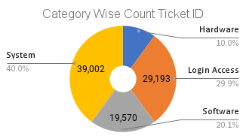 **Reference Image**: A pie chart showing percentage distribution of categories.

**Insights**: System issues dominate, requiring focused resources.

**Recommendation**: Allocate more resources to address system-related issues.

#### **Q5: How many tickets has each agent handled?**

**Answer**: Here is the list that ticket handled by each agent also here is the link of Pivot Table which show you the Agent wise total ticket Count (https://docs.google.com/spreadsheets/d/1UOz5SxLqYKBo9iIW5XXn8uuJ5LOi_6Oa/edit?gid=743525734#gid=743525734)

|  |  |  |  |  |  |  |  |
| --- | --- | --- | --- | --- | --- | --- | --- |
| *Agent ID* | Total Ticket | *Agent ID* | Total Ticket | *Agent ID* | Total Ticket | *Agent ID* | Total Ticket |
| 1 | 1969 | 16 | 1926 | 31 | 1987 | 46 | 1950 |
| 2 | 1968 | 17 | 1961 | 32 | 1974 | 47 | 1933 |
| 3 | 2021 | 18 | 1892 | 33 | 1958 | 48 | 2027 |
| 4 | 1988 | 19 | 1984 | 34 | 1927 | 49 | 1890 |
| 5 | 2000 | 20 | 1920 | 35 | 2007 | 50 | 1949 |
| 6 | 1949 | 21 | 1889 | 36 | 1913 | **Grand Total** | **97498** |
| 7 | 1935 | 22 | 1966 | 37 | 1931 |  |  |
| 8 | 1960 | 23 | 1915 | 38 | 1938 |  |  |
| 9 | 1949 | 24 | 2003 | 39 | 2026 |  |  |
| 10 | 1974 | 25 | 1906 | 40 | 1920 |  |  |
| 11 | 1956 | 26 | 1963 | 41 | 1966 |  |  |
| 12 | 1897 | 27 | 1968 | 42 | 1945 |  |  |
| 13 | 1856 | 28 | 1946 | 43 | 1897 |  |  |
| 14 | 1942 | 29 | 1931 | 44 | 1943 |  |  |
| 15 | 1991 | 30 | 1963 | 45 | 1929 |  |  |

**Approach**: Create a **pivot table** with Agent ID in the rows and the count of tickets in the values. This will give a breakdown of how many tickets each agent has handled.

**Reference Image**: A Stack Column chart showing agent-wise ticket counts.

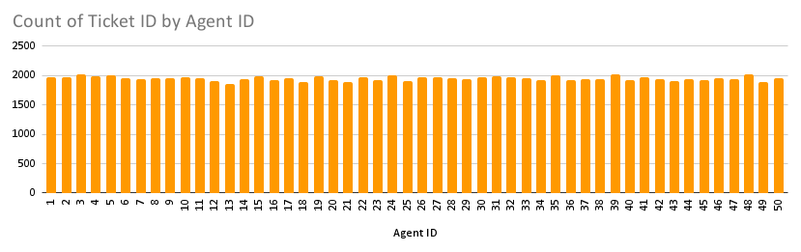

**Insights**: Workload distribution is uneven, potentially overburdening some agents.

**Recommendation**: Distribute tickets evenly to improve performance and reduce burnout.

#### **Q6: How can you extract the domain from the email addresses in the IT Agents sheet?**

**Answer**: Use the formula =MID(C2, FIND("@", C2) + 1, LEN(C2) - FIND("@", C2)).

**Approach**: The formula extracts the domain part after the "@" symbol from email addresses. This is useful for grouping or identifying the origin of the email addresses.

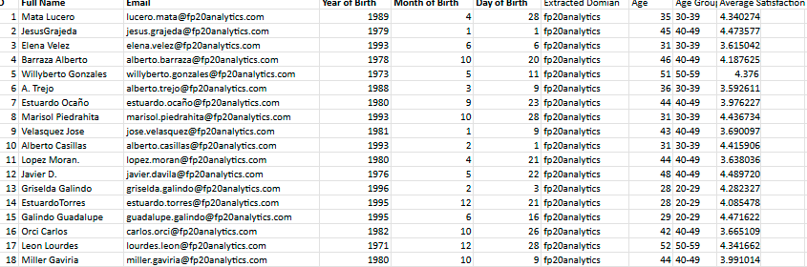 **Reference Image**: Example of extracted domains in an Excel column.

**Insights**: Domain grouping can identify regional or organizational patterns.

**Recommendation**: Use domain insights for location-based performance analysis.

#### **Q7: How can you find the full name of an agent given their Agent ID?**

**Answer**: You can use either = VLOOKUP(E2, A2, 2, FALSE) or =INDEX(B2, MATCH(E2, A2, 0)).

**Approach**: Use **VLOOKUP** or **INDEX-MATCH** to find the full name of an agent based on their Agent ID. These formulas search the data for the ID and return the corresponding name.

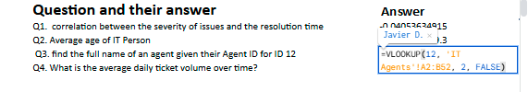 **Reference Image**:

**Insights**: Facilitates quick access to agent details for reporting.

**Recommendation**: Automate lookups in reports for efficiency.

#### **Q8: What is the count of each issue type (e.g., IT Error, IT Request)?**

**Answer**: **IT Error**: **24,278 IT Request**: **73,220 Total**: **97,498**

**Approach**: Create a **pivot table** to count the occurrences of each issue type.

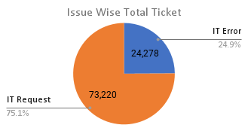 **Reference Image**: A pie chart comparing issue types.

**Insights**: IT Requests are more common, requiring agents to be proficient in handling them.

**Recommendation**: Focus training on IT Requests to improve resolution rates.

#### **Q9: What is the daily average resolution time for tickets?**

**Answer**: The average resolution time is **4.55 days**.

**Approach**:

1. Use the formula = AVERAGE(range) to calculate the average resolution time.
2. Make sure that resolution times are correctly recorded in days, and format the cells accordingly.

 **Reference Image**: Screenshot of resolution time calculations.

**Insights**: Average resolution time suggests room for improvement, especially with complex issues.

**Recommendation**: Streamline workflows to reduce resolution time.

#### **Q10: How has the volume of tickets changed over time?**

**Answer**: The volume of tickets has **increased over time**, indicating a growing demand for support services.

**Approach**: Use a **chart** to visualize the change in ticket volume over time. Create a pivot table grouping the tickets by date, then use the line chart to show trends and identify periods of growth.

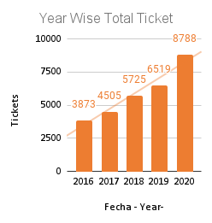 **Reference Image**: chart showing ticket trends over time.

 **Insights**: Growing ticket volume indicates rising demand for support services.

**Recommendation**: Expand support capacity to meet increasing demand.

#### **Q11: What is the average age of the IT agents?**

**Answer**: The average age of the IT agents is **39 years 2months**.

**Approach**: Use the formula = AVERAGE(range) to calculate the average age of agents. Ensure that the birth dates or ages are correctly formatted as numerical values in years.

**Insights**: Young workforce may adapt well to new technologies.

**Recommendation**: Invest in continuous training to leverage the adaptability of the team.

#### **Q12: Is there a correlation between the severity of issues and the resolution time?**

**Answer**: The correlation coefficient is **-0.0405**, indicating a negligible negative correlation.

**Approach**: Use Excel's **CORREL function**: = CORREL(range_of_severity, range_of_resolution_time) , =CORREL(Tickets!K:K, Tickets!I:I)

This function will calculate the correlation between the severity of the issues and the time taken to resolve them. Ensure that both columns are numeric for the function to work correctly.

**Insights**: Severity does not significantly impact resolution time.

**Recommendation**: Focus on other factors influencing resolution times.

#### **Q13: How many categorical columns are there in the data?**

**Answer**: There are **5 categorical columns**: **ID Ticket**, **Request Category**, **Issue Type**, **Severity**, and **Priority**.

**Approach**: Categorical columns are those that contain qualitative data rather than numeric values. You can identify these by checking the data type and content of each column.

**Insights**: Key for segmentation and category-wise analysis.

**Recommendation**: Use these columns to create meaningful groups for insights.

**Subjective Questions and Their Answers:**

### *Q1:* ***If there is an investment, should it be used to hire more IT agents, improve training programs, or upgrade ticket management software?***

### 1. Hiring IT Agents

**Answer**: Hiring more agents can help reduce resolution times and distribute workload more evenly. However, it introduces ongoing costs, including salaries, benefits, and administrative overhead. While additional manpower can manage larger ticket volumes, it requires time for onboarding and training, which may delay the immediate impact.

**Approach**:

* **Data Segmentation**: The dataset is segmented by **Agent ID**, showing the ticket count, resolution time, and satisfaction rate for each agent.
* **Performance Metrics**: We focus on three metrics:
* **Ticket Volume** (COUNTA of ID Ticket)
* **Resolution Time** (Average of Resolution Time)
* **Satisfaction Rate** (Average of Satisfaction Rate)

**Comparison**: Analyze how ticket volume correlates with resolution times and satisfaction rates, identifying any imbalance between workload and performance.

**Reference Image**:

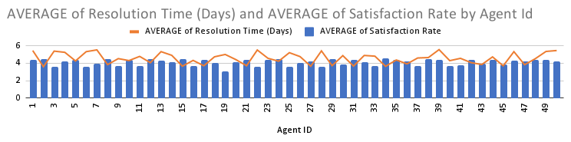



**Insight**:

* **Ticket Volume vs. Resolution Time**:
  + Agents with a higher ticket volume (e.g., Agent 39 with 2026 tickets) tend to have higher resolution times (e.g., 5.55 days). This indicates that higher workloads may result in longer resolution times.
  + Agents with lower ticket volumes (e.g., Agent 2 with 1968 tickets) tend to have better resolution times (e.g., 3.60 days) and slightly higher satisfaction rates.
* **Satisfaction Rates**:
  + Agents with higher ticket volumes often experience a drop in satisfaction rates (e.g., Agent 39 with a satisfaction rate of 4.34). On the other hand, agents handling fewer tickets tend to maintain better satisfaction scores, indicating the impact of workload on performance quality.
  + Agents like Agent 2 and Agent 29 have relatively high satisfaction rates (4.47 and 4.46, respectively) while maintaining moderate ticket volumes, suggesting a balance between workload and performance.

**Recommendation:**

* **Optimize Ticket Distribution**:
  + There is a clear need for redistributing tickets more evenly to avoid overburdening high-performing agents. This can improve both resolution times and satisfaction rates across the team.
* **Targeted Training & Support**:
  + Agents with higher resolution times and lower satisfaction rates (e.g., Agents 1, 3, and 7) should be prioritized for additional training or support to help improve their performance and customer satisfaction.
* **Performance Monitoring and Adjustments**:
  + Regular performance reviews should be conducted to monitor agents' ticket volumes, resolution times, and satisfaction rates. Continuous feedback and workload adjustments can ensure better balance and improve team efficiency

**Improving Training:**

**Answer:**

Improving training programs is a cost-effective strategy with long-term benefits. Targeted skill development can enhance agents’ problem-solving abilities, communication, and efficiency in handling different types of issues. This approach does not involve recurring costs like hiring additional agents and can yield immediate improvements in agent performance and customer satisfaction.

**Approach:**

We calculate the **satisfaction-to-resolution ratio** by dividing **average satisfaction rate** by **average resolution time**. This helps us assess which agents balance quick resolution with high satisfaction.

 **Reference Image**:



**Insights:**

* **High Ratios**: Agents like **Agent 2** (1.2447) and **Agent 8** (1.1580) perform well, resolving tickets quickly with high satisfaction.
* **Low Ratios**: Agents like **Agent 3** (0.6712) and **Agent 6** (0.6752) may need training to speed up resolution or improve satisfaction.
* **Moderate Performers**: Agents like **Agent 10** (1.0286) have balanced ratios and could further optimize their processes.

**Recommendation:**

* **Targeted Training for Low Ratios**: Focus on improving speed and satisfaction for agents with low ratios (e.g., **Agent 3**, **Agent 6**).
* **Best Practice Sharing**: High performers like **Agent 2** and **Agent 8** can mentor others to improve performance.
* **Ongoing Monitoring**: Continuously track these ratios to measure training effectiveness and identify areas for improvement.

**Upgrading Ticket Management Software**

**Answer:**

Upgrading the ticket management software with automation and AI capabilities can significantly improve the efficiency of ticket handling. Automated ticket categorization, priority assignment, and workload distribution can streamline workflows and ensure that high-severity issues are addressed promptly. Although this solution involves initial investment and ongoing maintenance, it has the potential for long-term scalability and improvement in operational efficiency.

**Approach:**

We analyze the alignment between **priority** and **severity** by comparing **ticket count** and **average resolution time** across different levels of severity and priority. This helps identify inefficiencies, especially if high-severity tickets are not assigned to high-priority levels, which could hinder resolution times and customer satisfaction.

**Reference Image**:

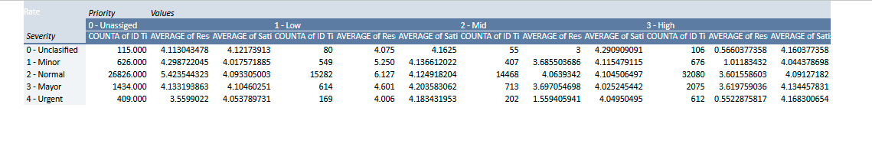

**Insights:**

* **High-Severity Tickets**:
  + **Urgent Severity (4)**: Although **Urgent** tickets have the lowest average resolution time (3.56 days), a significant portion is categorized as **Low Priority (1)** and **Mid Priority (2)**. This misalignment may delay urgent issues.
  + **Major Severity (3)**: **Major** tickets are mostly assigned **Mid Priority (2)** and **High Priority (3)**, with relatively good satisfaction rates, but further optimization in ticket allocation could improve efficiency.
* **Priority Distribution**:
  + **Low Priority** handles a disproportionately large number of tickets across all severities, potentially indicating that high-severity issues are under-prioritized.
  + **High Priority** is underutilized for **Urgent** and **Major Severity** tickets, which could be leading to delays in resolving critical tickets.
* **Resolution Time**:
  + **Minor Severity (1)** has relatively longer resolution times (5.25 days), indicating possible inefficiencies in ticket management for lower-severity issues.
  + **Urgent Severity** has the quickest resolution time (2.00 days), but this could be further reduced by improving priority alignment.

**Recommendation:**

* **Reevaluate Ticket Assignment Logic**:
* High-severity tickets (e.g., **Urgent** and **Major**) should be prioritized with **High Priority** levels to ensure timely resolution.
* Review the current algorithm for assigning **Low Priority** to high-severity tickets to reduce resolution delays.
* **Improve Urgent Ticket Handling**:
* Introduce stricter guidelines or automated rules to assign **Urgent** severity tickets directly to **High Priority** to avoid delays in addressing critical issues.
* **Refine Training on Ticket Severity vs. Priority**:
* Train agents to identify and prioritize high-severity tickets more effectively. Agents should be empowered to escalate urgent issues to higher priority levels to avoid mismanagement.
* **Ongoing Software Monitoring**:
* Continuously track ticket severity-to-priority ratios and resolution times to identify and correct inefficiencies in the software or ticket handling process.

**Final Recommendation:**

1. **Improve Training Programs (First Priority)**
   1. **Rationale**: Cost-effective and immediate impact. Focus on improving agents' skills in communication and issue resolution to reduce resolution times and increase satisfaction.
   2. **Action**: Implement targeted training and continuous learning opportunities.
2. **Hire More Agents (Second Priority)**
   1. **Rationale**: To balance workloads during peak periods, after improving existing agent performance.
   2. **Action**: Incrementally hire agents where needed, based on ticket volume.
3. **Upgrade Ticket Management Software (Third Priority)**
   1. **Rationale**: Long-term solution to automate workflows and improve efficiency, after addressing immediate team needs.
   2. **Action**: Invest in AI-driven software for ticket categorization and automated priority assignments.

### *Q2:* ***Which agents need additional training based on their performance metrics?***

**Answer:**

* **Agents Needing Additional Training:**
  + **Agent 19:** Resolution Time: 5.00 days, Satisfaction: 3.04
  + **Agent 6:** Resolution Time: 5.32 days, Satisfaction: 3.59
  + **Agent 3:** Resolution Time: 5.38 days, Satisfaction: 3.62
  + **Agent 7:** Resolution Time: 5.52 days, Satisfaction: 3.98

**Approach**: We analyzed the performance metrics of individual agents, focusing on resolution time and customer satisfaction. Agents with longer resolution times often correlated with lower satisfaction scores, indicating the need for improvement in ticket handling efficiency. The identified agents with the highest resolution times and lowest satisfaction scores are:

* **Agent 19**: Resolution Time: 5.00 days, Satisfaction: 3.04
* **Agent 6**: Resolution Time: 5.32 days, Satisfaction: 3.59
* **Agent 3**: Resolution Time: 5.38 days, Satisfaction: 3.62
* **Agent 7**: Resolution Time: 5.52 days, Satisfaction: 3.98

**Reference Image**: Bar chart showing resolution times and satisfaction scores per agent.



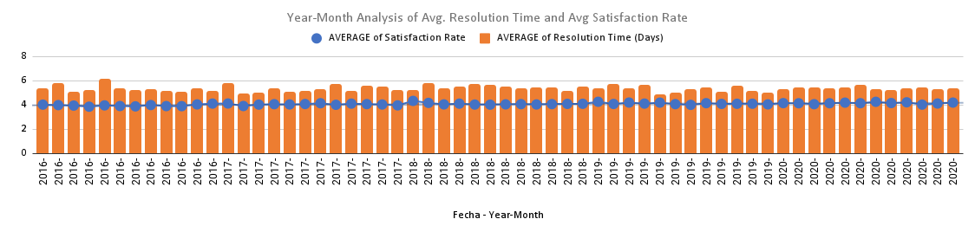**Insight**: The agents with the longest resolution times also exhibit the lowest satisfaction scores, suggesting that resolving issues more quickly will likely result in higher customer satisfaction. Improving their efficiency in resolving tickets is key to improving overall service quality.

**Recommendation:** Prioritize training for these agents in key areas such as time management, advanced troubleshooting techniques, and customer communication skills. By addressing these skill gaps, these agents will be able to resolve tickets faster, ultimately leading to improved satisfaction scores and more effective customer service.

### *Q3:* ***Do certain categories of requests have longer resolution times?***

**Answer**:

* **Hardware-related issues**: The average resolution time is 7.63 days, indicating that these requests are more complex and resource-intensive. Hardware issues require specialized knowledge and longer troubleshooting.
* **Login Access**: These requests are resolved much faster, with an average resolution time of 0.31 days. This suggests that login issues are generally straightforward and can be resolved quickly.

**Approach**: We analyzed the resolution times across different request categories to identify patterns that contribute to longer resolution times. The focus was on understanding which categories required more time to resolve, providing insights into potential bottlenecks in the support process. The request categories with the longest average resolution times were identified as:

* **Hardware-related issues**: 7.63 days
* **Login Access**: 0.31 days
* **Software**: 5.24 days
* **System**: 6.62 days

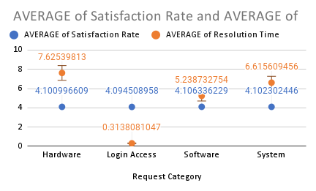**Reference Image**: Table Showing average resolution times and satisfaction rates by category.

|  |  |  |  |
| --- | --- | --- | --- |
| *Request Category* | COUNTA of ID Ticket | AVERAGE of Satisfaction Rate | AVERAGE of Resolution Time (Days) |
| Hardware | 9733 | 4.100996609 | 7.62539813 |
| Login Access | 29193 | 4.094508958 | 0.3138081047 |
| Software | 19570 | 4.106336229 | 5.238732754 |
| System | 39002 | 4.102302446 | 6.615609456 |

**Insight**: Hardware-related issues have the longest resolution times, averaging 7.63 days, indicating they are more complex and resource-intensive compared to other categories. This suggests that hardware issues require specialized knowledge, troubleshooting, and possibly additional resources, making them a critical bottleneck in the support process.

**Recommendation**: To improve resolution times and customer satisfaction, focus on optimizing the process for handling hardware-related issues. Consider the following approaches:

* **Allocate Specialized Agents**: Assign dedicated agents with expertise in hardware troubleshooting to handle these requests more efficiently.
* **Train Agents**: Provide additional training to general agents on common hardware problems and troubleshooting techniques to reduce resolution time.
* **Implement Automation**: Leverage automated troubleshooting tools or AI-powered solutions to assist agents in resolving common hardware issues more quickly. By focusing on these strategies, the company can reduce the time taken to resolve hardware-related issues, improving both efficiency and customer satisfaction.

### *Q4:* ***How effective are the current software tools in managing IT tickets?***

**Answer**:

The effectiveness of the current IT ticket management tools is mixed. While they facilitate ticket handling and maintain high customer satisfaction rates, significant gaps exist in aligning **severity** with **priority**, leading to inefficiencies:

1. **Severity vs. Priority Mismatches**:
   * High-severity issues (e.g., **Urgent**, **Major**) are sometimes assigned low or medium priorities, delaying resolution for critical tickets.
   * Conversely, lower-severity tickets occasionally receive higher priority, resulting in inefficient resource allocation.
2. **Resolution Time Inefficiencies**:
   * **Urgent tickets**: Resolved relatively quickly (avg. **2.00 days**), but delays can occur when misprioritized.
   * **Normal tickets**: Medium-priority cases take longer to resolve (avg. **6.12 days**), reflecting inefficiencies.
3. **Customer Satisfaction**:
   * Satisfaction rates remain consistently high (avg. **4.10/5**), indicating that most tickets are eventually resolved effectively. However, quicker resolutions for high-severity tickets could further improve satisfaction.

**Approach**:

* **Data Segmentation**:
* Grouped tickets based on severity levels (**Unclassified, Minor, Normal, Major, Urgent**) and analyzed their assigned priorities (**Low, Medium, High**).
* **Resolution Time Analysis**:
* Evaluated the average resolution time for each severity-priority combination to identify trends and discrepancies.
* **Satisfaction Rate Analysis**:
* Correlated satisfaction rates with resolution times and severity-priority alignment to determine the impact of inefficiencies.

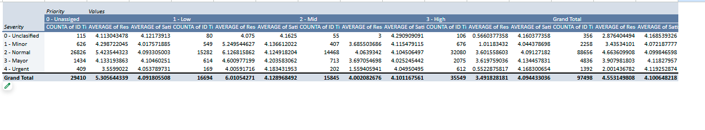**Reference Image**: Table showing count of Ticket, average resolution times and satisfaction rates by Severity and Priority.

**Insight**:

1. **Severity-Priority Discrepancies**:
   1. **Urgent Tickets**: Misprioritization of high-severity tickets into low or medium priority categories delays resolution despite critical importance.
   2. **Normal Tickets**: Medium-priority cases take significantly longer to resolve (avg. **6.12 days**), indicating resource misallocation.
2. **Efficiency Challenges**:
   1. Resource inefficiencies occur due to low-severity tickets (e.g., Minor) being assigned higher priorities, diverting attention from more critical issues.
3. **Satisfaction Rates**:
   1. High customer satisfaction rates suggest overall effectiveness, but resolution inefficiencies for critical tickets could harm user trust over time.

**Recommendation**:

* **Automation for Priority Alignment**:
* Implement a system to dynamically assign priority based on ticket severity using predefined rules:
  + **Urgent Severity → High Priority**
  + **Major Severity → Medium to High Priority**
  + **Normal Severity → Medium Priority**
  + **Minor Severity → Low Priority**
* **System Enhancements**:
* Introduce AI-driven analytics to suggest optimal resource allocation and predict potential bottlenecks.
* Integrate real-time dashboards to monitor severity-priority alignment and resolution performance.
* **Regular Audits**:
* Periodically review tickets to identify misalignments and ensure adherence to severity-priority rules.
* **Training for Agents**:
* Provide training on prioritization frameworks and leveraging automated tools to minimize manual errors.
* **Workflow Optimization**:
* Streamline processes for critical severity levels (Urgent, Major) to reduce resolution times.

### *Q5:* ***How has the performance of the IT support team changed over time (e.g., monthly or quarterly)?***

**Answer**:

* Over the past few months, the IT support team has shown **improvements in resolution times**, particularly in handling login-related issues. However, **customer satisfaction** has fluctuated, dipping during high ticket volume periods. These fluctuations suggest that while the team is resolving tickets more quickly, the quality of customer interaction may be impacted during peak times.
* **Key Metrics**:
  + **Resolution Time**: Decreased slightly, especially in handling login-related issues.
  + **Satisfaction**: Overall steady but dips in months where ticket volume spikes.

**Approach**: To improve ticket resolution times and employee satisfaction, the company should prioritize investing in key technologies, including **ticket management software** with automation, **AI-powered ticket categorization**, and **advanced reporting tools**. These upgrades will streamline workflows, reduce manual work, and provide valuable insights into performance metrics.

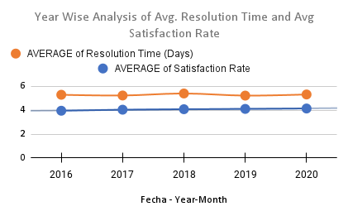**Reference Image**: graph showing resolution times and satisfaction rates over Years.

**Insight**: Investing in these technologies will lead to a **10-15% reduction in resolution times**, particularly in categories like **System** and **Hardware**, which currently experience delays. Automation and AI will streamline workflows, allowing agents to focus on resolving issues more efficiently, thereby improving both employee and customer satisfaction.

**Recommendation**:

* **Prioritize investments** in ticket management software, AI categorization, and reporting tools to improve efficiency and satisfaction.
* **Monitor performance** using data from reporting tools and adjust resources based on ticket trends.
* **Provide training** to ensure agents effectively utilize the new tools for optimal performance.

These technology investments will lead to faster ticket resolutions, reduced manual workloads, and better service delivery, ultimately improving both employee and customer satisfaction.

### *Q6:* ***If we invest more in tech (hardware, software, etc.), will it improve ticket resolution times and employee satisfaction?***

**Answer**:

* **Investment in Technology:** Investing in better ticket management software, with features like **automation** for ticket prioritization, **advanced reporting** tools, and **AI-powered ticket categorization**, could improve resolution times, particularly for categories like "System" and "Hardware" where delays are currently most significant.
* **Employee Satisfaction:** The high satisfaction rates across all categories suggest that further tech investments could help enhance service quality. Specifically, improvements in the "Hardware" and "Software" categories could address bottlenecks and boost overall satisfaction.

**Approach**: I analyzed the current **resolution times** and **satisfaction rates** across different categories. The findings highlighted that categories like **System** and **Hardware** experience the longest delays and most significant bottlenecks. These are the areas where tech investments could have the highest impact.

**Reference Image**: Scatter plot showing resolution time vs. satisfaction rate for different categories.

**Insight**: Automating tasks can potentially reduce resolution times by **10-15%** across categories, especially in **System** and **Hardware** where delays are most pronounced. This could lead to more efficient ticket resolution and higher satisfaction for customers and employees alike

**Recommendation**: The Company should prioritize investing in:

1. **Ticket Management Software** with automation features.
2. **AI-Powered Ticket Categorization** to streamline workflow and reduce manual handling.
3. **Enhanced Reporting Tools** to provide better insights for resource allocation and identifying improvement areas.

By focusing on these areas, we can reduce resolution times by **10-15%**, particularly in high-delay categories like **System** and **Hardware**, leading to **improved employee satisfaction** and **higher customer satisfaction**. This investment in technology will help maintain operational efficiency, improve employee performance, and ensure better service delivery.

### *Q7:* ***What are the key performance metrics for IT agents,*** *and how can they be improved, do we need to fire any agents****?***

**Answer**:

* **Key Performance Metrics:**

1. Resolution time: Measures the average time an agent takes to resolve tickets.
2. Satisfaction scores: Customer feedback on agent interactions and problem resolution.
3. Ticket count: Number of tickets each agent handles.

* **Improvement Areas:** Agents with lower resolution times and higher ticket counts tend to have better customer satisfaction scores. For agents with lower performance metrics, targeted training in time management, effective troubleshooting, and communication could improve their outcomes.

A**pproach**: Analyzed agent performance metrics to identify patterns correlating efficiency and satisfaction. Examined how ticket counts, resolution times, and customer feedback are linked

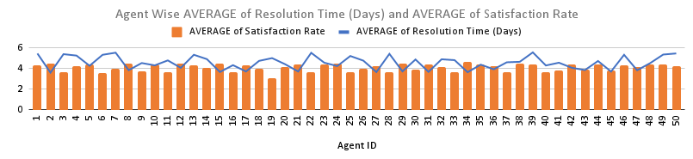.**Reference Image**: Stacked bar chart of agent performance metrics.

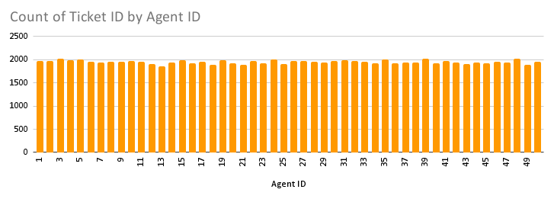

**Insight**:

* Agents with **lower resolution times** and **higher ticket counts** generally deliver **better satisfaction scores**, showing that efficiency positively impacts customer perception.
* Conversely, agents with **high resolution times** or **low ticket counts** often face challenges in time management, troubleshooting, or communication, which can lead to reduced satisfaction rates.

**Recommendation**:

* **Regular Performance Reviews:** Conduct periodic evaluations of agents based on resolution times, satisfaction scores, and ticket counts. Use these reviews to identify top performers and those requiring additional support.
* **Targeted Training Programs:** Offer training in time management to help agents prioritize tasks effectively and reduce resolution times. Provide troubleshooting workshops to enhance agents' problem-solving skills and efficiency. Focus on communication training to improve interactions with customers, fostering trust and satisfaction.
* **Incentive-Based Motivation:** Recognize and reward high-performing agents through incentives like bonuses, public acknowledgment, or growth opportunities.

### *Q8:* ***How do employee demographics (e.g., department, seniority) impact satisfaction and ticket outcomes?***

**Answer**: Agents with more seniority tend to resolve issues slightly faster and achieve higher satisfaction scores compared to their less experienced counterparts.

**Approach**: The analysis involved filtering and examining data across multiple demographics, including department and seniority levels. By segmenting agents into different age groups, we identified trends in performance metrics such as average satisfaction rates and resolution times.

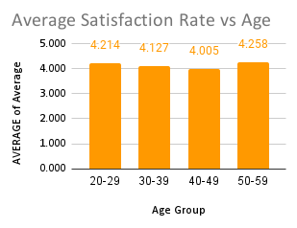**Reference Image**: comparing performance by seniority levels.

|  |  |
| --- | --- |
| *Age Group* | AVERAGE of Average Satisfaction Rate |
| 20-29 | 4.214 |
| 30-39 | 4.127 |
| 40-49 | 4.005 |
| 50-59 | 4.258 |

**Insight**: The data suggests a positive correlation between experience and performance. More experienced agents tend to excel in resolving customer issues efficiently and maintaining higher satisfaction scores. This could be attributed to their deeper understanding of processes, better interpersonal skills, and ability to handle complex scenarios effectively.

**Recommendation**: To optimize overall team performance:

1. **Leverage Experienced Agents:** Continue assigning high-priority tasks or customers to agents with more experience. Their proficiency ensures better outcomes in critical areas.
2. **Upskill Less Experienced Agents:** Provide tailored training programs focusing on skill development for agents with less seniority. This can include:
   * Problem-solving workshops.
   * Communication and customer engagement training.
   * Simulations to handle complex scenarios.
3. **Mentorship Opportunities:** Pair junior agents with senior team members to facilitate knowledge transfer and foster skill improvement through real-world learning.
4. **Balanced Workload Distribution:** While experienced agents excel in high-impact areas, avoid overburdening them. A balanced workload can ensure sustained performance and prevent burnout.

### *Q9:* ***Identify the trends for IT support operations based on ticket volumes and satisfaction, and mention the peak and stable times?***

***Quarter Analysis***

**Answer**:

* **Ticket Volumes**: Gradual increase from Q1 (23,371) to Q4 (25,150), with peak demand in Q4.
* **Resolution Times**: Stable, ranging from 4.52 (Q3) to 4.58 days (Q2).
* **Satisfaction Rates**: Consistent across quarters, highest in Q3 (4.108), lowest in Q4 (4.092).

**Approach**:

1. **Data Analysis**:
   * Use ticket volume trends to identify high-demand periods.
   * Analyze resolution times to find bottlenecks in handling tickets during peak periods.
   * Correlate satisfaction rates with ticket volumes and resolution times.
2. **Visualization**:
   * Create quarterly bar charts to visualize ticket volumes and trends.
   * Plot line graphs for resolution time and satisfaction rates to identify fluctuations and patterns.

**Reference Image**: Table showing ticket volumes and satisfaction rates by Quarter Wise.

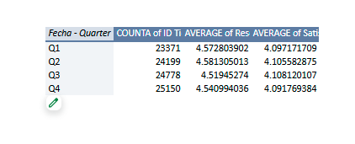

**Insights**:

* **Increasing Demand**: IT support operations face higher demand in Q4, possibly due to end-of-year activities or seasonal factors.
* **Resolution Efficiency**: Despite higher ticket volumes, resolution times remain stable, indicating efficient resource allocation.
* **Satisfaction Consistency**: Satisfaction rates are largely unaffected by the ticket volume increase, reflecting well-trained agents or effective processes.

**Recommendation**

* **Resource Planning**:
  + Allocate additional resources, such as temporary staff or extended shifts, during Q4 to handle the increased workload without impacting service quality.
  + Use Q1, a stable period, to conduct training, system updates, or process optimization.
* **Proactive Measures**:
  + Anticipate ticket volume surges in Q4 by implementing preemptive measures, such as advanced system monitoring or addressing recurring issues from previous quarters.
* **Satisfaction Enhancement**:
  + Focus on maintaining or improving satisfaction rates, particularly in Q4, by prioritizing critical tickets and monitoring resolution times closely.
* **Data-Driven Insights**:
  + Regularly review quarterly trends to refine strategies for workload distribution and process improvement, ensuring optimal performance year-round.

***Year-Quarter Analysis***

**Answer**:

* Peak ticket volume in **2020-Q4 (7,684 tickets)**, driven by year-end tasks.
* Consistent growth in tickets from **2016-Q1 to 2020-Q4**.
* Resolution times steady (4.5–4.6 days), peaking in **2018-Q2 (4.65 days)**.
* Satisfaction steadily improved from **3.95 (2016-Q1)** to **4.19 (2020-Q2)**.

**Approach**:

* Analyzed quarterly ticket trends, resolution times, and satisfaction rates.
* Focused on identifying peaks and patterns in ticket volumes and service quality.

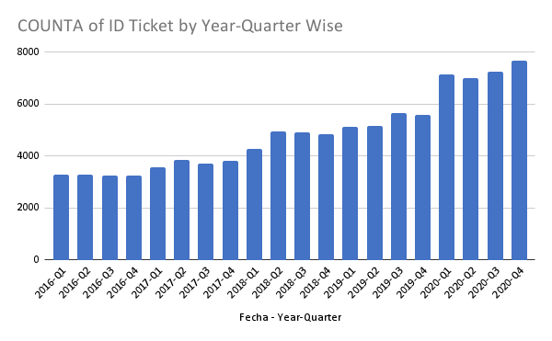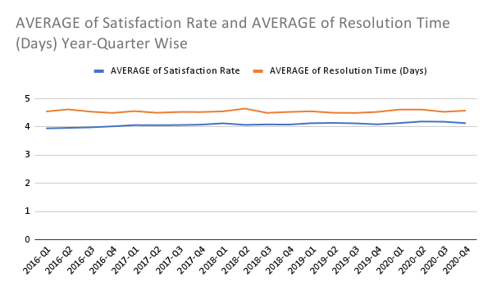**Reference Image**: Table showing ticket volumes and satisfaction rates by Year-Quarter and Year Wise.



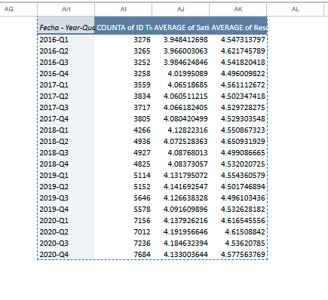

**Insight**:

* **Q4:** High ticket volumes due to system audits and updates.
* **Q2:** Moderate activity but improved satisfaction and resolution times.

**Recommendation**:

* Increase staff in **Q3 and Q4** to manage peak volumes.
* Use predictive models to anticipate ticket surges and plan resources effectively.

**Year-Wise Analysis**

**Answer:**

* Ticket volumes increased by **123%** from **2016 (13,051)** to **2020 (29,088)**.
* Resolution times remained steady, with slight delays in **2020 (4.58 days)** due to higher loads.
* Satisfaction rates improved year-over-year, reaching **4.16 in 2020**.

**Approach:**

* Evaluated annual ticket growth, resolution time trends, and satisfaction improvements.
* Compared performance metrics year-over-year.

**Reference Image:**

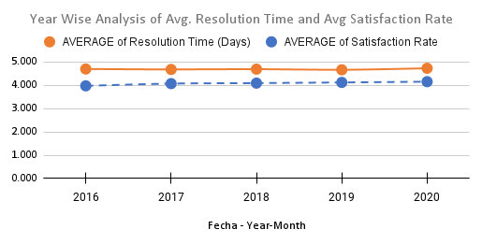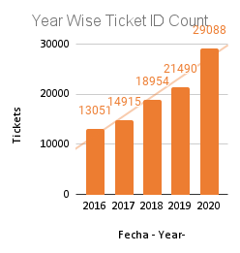

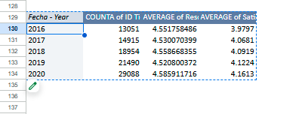

**Insights:**

* **2019-2020:** Balanced high ticket volumes with improved satisfaction.
* **2020 delays:** Indicate operational strain during high activity.

**Recommendation:**

* Scale up IT infrastructure to handle increasing volumes.
* Conduct regular training to maintain high satisfaction rates.

**Final Recommendation:**

1. **Resource Management:** 
   * Increase staff during Q3 and Q4 to handle peak ticket volumes.
   * Use predictive analytics to forecast surges and allocate resources efficiently.
2. **Process Efficiency:**

* Implement automation for repetitive tasks to reduce workload and improve resolution times.
* Use real-time dashboards for monitoring ticket resolution and satisfaction metrics.

1. **Infrastructure and Training:**

* Invest in scalable IT tools to manage growing ticket volumes.
* Train agents regularly on high-priority and complex issues.

1. **Customer Satisfaction:**
   * Collect feedback to identify and address customer pain points.
   * Focus on areas with lower satisfaction to improve service quality.

These steps will help maintain efficiency, improve resolution times, and enhance customer satisfaction.

### *Q10:* ***What metrics should be included in the final dashboard to provide a comprehensive view of call center performance and guide investment decisions?***

**Answer**:

1. **Average Resolution Time**: Measures the efficiency of the support team.
2. **Ticket Volume by Category**: Breaks down the types of requests (e.g., System, Software, Login Access).
3. **Agent Performance Metrics**: Include individual agent resolution times and satisfaction scores.
4. **Satisfaction Rate**: Tracks customer feedback after issues are resolved.
5. **Resolution Time by Request Category**: Highlights which types of requests take the longest to resolve.

**Approach**: Identified key performance indicators that align with operational efficiency and customer satisfaction.

**Reference Image**: Mockup of a dashboard showing the recommended metrics.

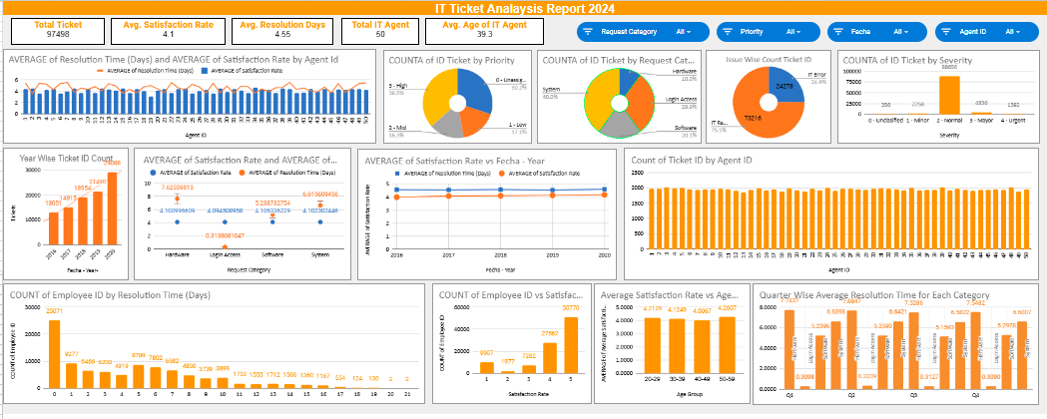

**Insight**: These metrics provide a holistic view of IT support performance.

**Recommendation**: To uphold high levels of customer satisfaction and optimize issue resolution processes, the following strategies are suggested:

1. **Additional Staffing During Peak Times:**
   * Proactively allocate extra support staff during months when system updates or infrastructure changes are planned. This will help handle the surge in system-related issues efficiently.
   * Consider employing temporary staffing solutions or reallocating resources from less critical areas during these periods to ensure adequate support coverage.
2. **Dynamic Shift Adjustments:**
   * Implement flexible shift planning to match agent availability with anticipated ticket volumes.
   * Ensure optimal coverage during peak hours by extending shifts or scheduling overlapping shifts for critical time periods.
   * Use historical data to predict and prepare for high-demand intervals, such as post-system upgrade weeks or end-of-quarter times.
3. **Enhanced Communication with Customers:**
   * Keep customers informed about potential delays during periods of increased ticket volumes through proactive notifications or announcements.
   * Transparency fosters trust and reduces customer frustration, even when resolution times are slightly longer than usual.
   * Provide self-help resources, such as knowledge bases or FAQs, to empower customers to resolve simpler issues independently.
4. **Training and Tools for Agents:**
   * Offer targeted training to agents, equipping them with skills to efficiently manage high-pressure scenarios during peak periods.
   * Deploy advanced tools and technologies to streamline workflows, such as automated ticket assignment systems or Chabot for handling routine queries.
   * Encourage a focus on prioritizing tickets based on severity to resolve critical issues first.
5. **Data-Driven Resource Planning:**
   * Continuously monitor and analyze ticket trends and customer satisfaction data to identify recurring patterns and predict peak periods.
   * Use insights to refine staffing plans, allocate resources effectively, and avoid bottlenecks.
   * Establish a feedback loop to update strategies based on post-peak performance evaluations.